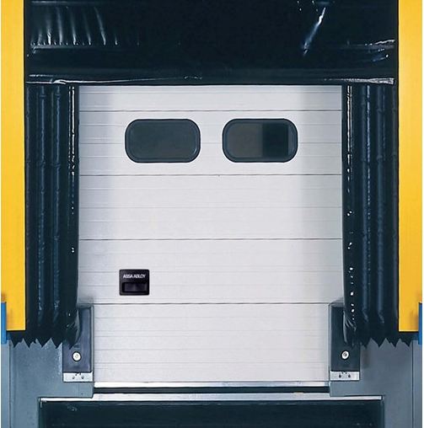

Sr. No | Specification | NIHVA ASSA Abloy Inflatable Dock Shelter
1 | Door type | Inflatable Dock Shelter DS6070B
2 | Nominal Depth | 700, 1020 mm
3 | Top Bag Extension | 1000 mm
4 | Side Bag Extension | 650mm
5 | Walls and Roofs | Insulated panel, 42 mm
6 | Fabric Quality | PVC Coated Polyester
7 | Top Bag | 500 g/m2, Thickness 0.5mm
8 | Side Bag Rear | 600 g/m2, Thickness 0.5mm
9 | Side Bag Front | 2500 g/m2, thickness 2mm
10 | Fan | 230 V, 1 Phase, 50Hz, 250W
11 | Operating | Switch Control Included
12 | Temperature Range | -30 Degree to +60 Degree

